Sanat Tokmagambet
Software Engineer / AI Engineer
English — IELTS Academic 7.5| Russian(native speaker)| Kazakh(native speaker)
https://github.com/santaklaussus2004 Sanat Tokmagambet | LinkedIn
Astana, Kazakhstan | Previously based in Passau, Germany| santaklaussus2004@gmail.com | +7 778 900 96 52 (KZ) | +49 15510 9687 88 (DE)

PROFILE

AI/ML Engineer | Python | LLM Systems

AI/ML Engineer with hands-on experience building end-to-end LLM applications, RAG pipelines, Telegram-based AI systems, and custom machine learning projects in Python.
Built AI products involving semantic retrieval, vector databases, persistent user context, multimodal inputs, authentication, payment workflows, and automated document generation.
Implemented and trained a GPT-style Transformer language model from scratch, including attention mechanisms, forward/backward propagation, gradient computation, parameter updates, and autoregressive text generation.
Strong focus on understanding ML systems under the hood and turning research ideas into working, user-facing AI products.

Personal Project — Transformer Language Model Built Completely from Scratch
• Built and trained a GPT-style Transformer language model from scratch in PyTorch, following the architecture introduced in “Attention Is All You Need”.

• Manually implemented forward/backward propagation, gradient calculations, parameter updates, causal multi-head self-attention, feed-forward layers, residual connections and normalization; used PyTorch primarily for low-level tensor operations rather than prebuilt Transformer modules.

• Built the training and autoregressive generation pipeline and trained the model locally on literary text datasets

.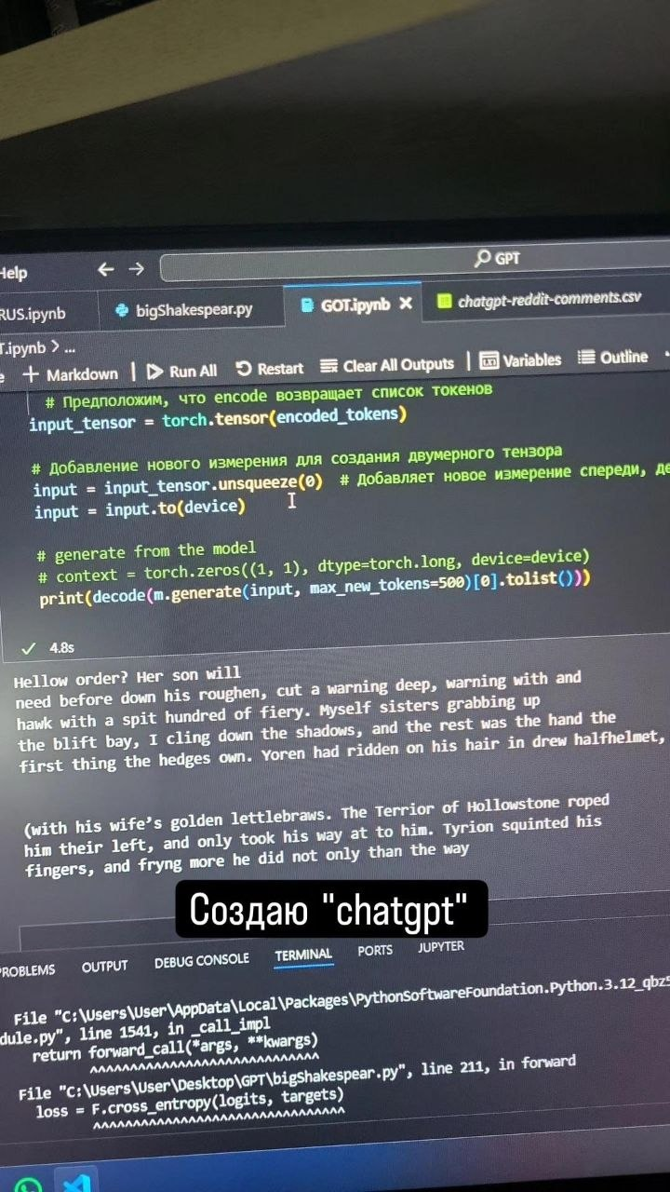
Autoregressive text generation from a custom Transformer language model implemented and trained in PyTorch
Technical Skills
Programming | Python
ML & Deep Learning | PyTorch · scikit-learn · NumPy · pandas · Neural Networks · Transformers
LLM & RAG | OpenAI API · Embeddings · Vector Databases · Semantic Search · Cosine Similarity · Retrieval Pipelines · Prompt Engineering
Backend & Integrations | Telegram Bot API · REST APIs · Authentication · User State Management · PDF Generation · Payment Integration
Developer Tools | Git · GitHub · Jupyter · VS Code

EXPERIENCE

AI & Python Developer — Nusa Corporation
Aru-bot
- Built an AI-powered Telegram assistant for survivors of gender-based violence in Kazakhstan, providing legal guidance, support resources, and next-step recommendations.
- Developed an LLM/RAG pipeline that extracts legal concepts from user messages and retrieves relevant information using vector search and cosine similarity.
- Generated structured guidance and ready-to-use PDF police statements based on user-provided case details.
- Tech: Python · Telegram Bot API · OpenAI API · Vector Databases · RAG · PDF Generation

ChatHitch — Founder / Developer
- Built a context-aware Telegram AI assistant that analyzes communication history with a specific person and provides personalized recommendations.
- Implemented chronological interaction tracking, persistent person profiles, user goals, and multimodal inputs including text, voice, and images.
- Generated contextual advice, communication strategies, key interaction insights, and suggested responses using stored relationship history.
Tech: Python · Telegram Bot API · OpenAI API · Multimodal Inputs · Stateful Context Management

Sanau Education — Founder / Developer
- Built a Telegram-based mathematics learning platform for students in grades 5–11 with structured lessons, homework, reminders, and subscription-based access.
- Implemented authentication, course progress workflows, video learning materials, and an AI learning assistant.
- Developed an end-to-end automated Kaspi payment flow with payment links, automatic receipt verification, and automatic course unlocking.
Tech: Python · Telegram Bot API · OpenAI API · Payment Integration · Authentication · User State Management
Math / Physics Teacher
Abay Academy | Aug 2023 - Jun 2024
Prepared students in grades 5-9 for regular school success in Mathematics and Physics.

EDUCATION

M.Sc. in AI Engineering
University of Passau | In progress
• Admitted to the M.Sc. in AI Engineering program and completed one semester, but chose to focus on practical ML engineering, real-world AI product development, and industry experience.
B.S. in Software Engineering
Astana IT University | Sep 2022 - Jun 2025
• Built a foundation in programming, software development, system design, collaboration, and hands-on engineering projects.

